1.
Prove mathematical induction

2.
Asymptotes : 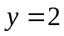 , 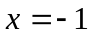 , 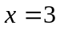
Local minimum point : 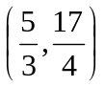 , local maximum point : 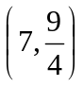
Axial intercepts : 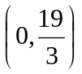 , 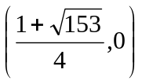 , 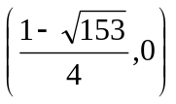

3.
(i) 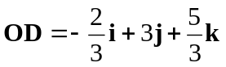
(ii) 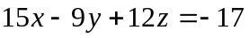
(iii) 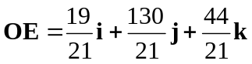
(iv) 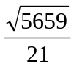

4.
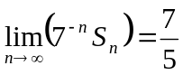

5.
(i)   